**HANOI UNIVERSITY OF SCIENCE AND TECHNOLOGY**

**SCHOOL OF ELECTRONICS AND TELECOMMUNICATIONS**

**---🙠**🕮**🙢---**



**APPLIED SOFTWARE ENGINEERING**

**PROJECT REPORT**

**Lecturer: Lê Thị Lan**

**Course Code: ET3260E**

**Class Code: 136286**

**Semester: 2022.1**

**Group: 4**

**PROJECT: Design and develop an application for home appliance control using hand gestures.**

**GROUP MEMBERS**

|  |  |  |  |
| --- | --- | --- | --- |
| **STT** | **Họ tên** | **Lớp** | **MSSV** |
| 1 | Dương Nhật Nam | CTTT Điện tử 01 K65 | 20203803 |
| 2 | Nguyễn Phạm Anh Tuấn | CTTT Điện tử 01 K65 | 20203827 |

TABLE OF WORK RESUME:

|  |  |  |  |  |
| --- | --- | --- | --- | --- |
| No | Name | Student ID | Role | Work assignment |
| 1 | Dương Nhật Nam | 20203803 | Leader | * Designs and codes for database. * Codes for the application * Writes report. * Makes Slides * Presents |
| 2 | Nguyễn Phạm Anh Tuấn | 20203827 | Member | * Designs ER, RR, Use case, system requirements, Activity diagram * Testing |

1. **Introduction**

In recent years, the rise of smart homes and the Internet of Things (IoT) has led to the development of various technologies aimed at improving home automation and convenience. One such technology is the use of hand gestures to control home appliances.

This application leverages the power of machine learning and computer vision to recognize and interpret hand gestures, enabling users to control their home appliances without having to physically interact with them. With this application, users can easily turn on or off their lights, fans, air conditioners, or any other home appliance by simply gesturing in the air.

1. **Requirements**
2. **Functional requirements**

* Admin:
* Login
* Manage Users:

+ Browse all users.

+ Delete a user.

* Manage Rooms:

+ Browse all rooms

+ Add a room.

+ Delete a room.

* User:
* Sign up for an account
* Sign in
* Change Password
* Select room

1. **Non - Functional requirements**

* Performance: The application should have a fast response time to recognize and interpret hand gestures, and it should work smoothly without any lag or delays.
* Security: The application should have robust security measures to protect users' data and prevent unauthorized access to their home appliances.
* Reliability: The application should be reliable and should work consistently without any crashes or downtime.
* Usability: The application should be user-friendly and easy to use, even for non-technical users. It should have clear instructions, intuitive gestures, and a simple interface.
* Compatibility: The application should be compatible with a wide range of home appliances and should work with different brands and models.
* Scalability: The application should be scalable and able to handle a large number of users and devices without affecting its performance.
* Accessibility: The application should be accessible to all users, including those with disabilities, by providing options for different types of gestures and feedback mechanisms.
* Availability: The application should be available 24/7, and any issues should be resolved quickly to ensure that users can always control their home appliances.
* Maintenance: The application should be easy to maintain and update, and any bugs or issues should be fixed promptly.
* Privacy: The application should respect users' privacy and should not collect or share their personal data without their consent.

1. **System Design**
2. **Use case diagram**

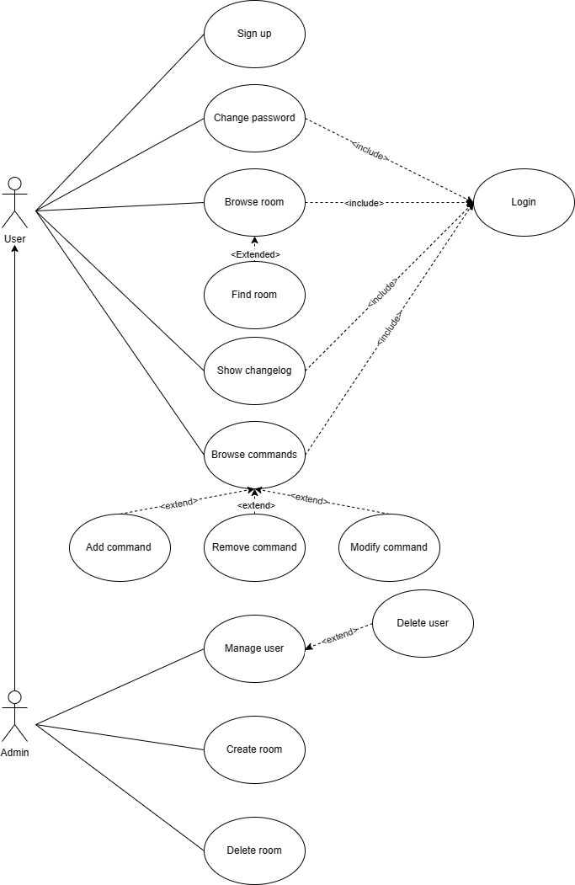

1. **System requirements**

|  |  |
| --- | --- |
| Identifier | User story |
| REQ-1: | As a user I can create my account. |
| REQ-2: | As a user I can login an account. |
| REQ-3: | As a user I can change my account’s password. |
| REQ-4: | As an admin I can remove a user. |
| REQ-5: | As an admin I can grant a user access to manage a room. |
| REQ-6: | As an admin I can disable a user’s access to manage a room. |
| REQ-7: | As an admin I can create a room. |
| REQ-8: | As an admin I can remove a room. |
| REQ-9: | As a user I can browse all room in the house. |
| REQ-10: | As a user I can find all room I have access to control. |
| REQ-11: | As a user I can browse commands in a room. |
| REQ-12: | As a user I can add, remove, or change meaning of commands in a room I have access. |
| REQ-13: | As a user I can see the history of a command’s modification. |

|  |  |  |  |
| --- | --- | --- | --- |
| Initiator | Initiator’s Goal | Participants | Usecase |
| Admin, User | Login | Database | Login  (UC-1) |
| User | Sign up | Database | Sign up  (UC-2) |
| User, Admin | Change password | Database | Change password  (UC-3) |
| Admin | Grant a user’s access to a room or | Database | Grant access  (UC-4) |
| Admin | Disable a user’s access to a room | Database | Disable access  (UC-5) |
| Admin | Delete a user | Database | Delete user  (UC-6) |
| Admin | Create a room | Database | Create room  (UC-7) |
| Admin | Delete a room | Database | Delete room  (UC-8) |
| User | Browse room | Database | Browse room  (UC-9) |
| User | Find room | Database | Find room  (UC-10) |
| User | Browse commands | Database | Browse commands  (UC-11) |
| User | Add command | Database | Add command  (UC-12) |
| User | Remove command | Database | Remove command  (UC-13) |
| User | Change meaning of command | Database | Modify command  (UC-14) |
| User | Show changelog of a command | Database | Show changelog  (UC-15) |

Table 2.1 Deriving use cases from System Requirements

|  |  |  |  |  |  |  |  |  |  |  |  |  |  |  |  |
| --- | --- | --- | --- | --- | --- | --- | --- | --- | --- | --- | --- | --- | --- | --- | --- |
| REQs | UC1 | UC2 | UC3 | UC4 | UC5 | UC6 | UC7 | UC8 | UC9 | UC10 | UC11 | UC12 | UC13 | UC14 | UC15 |
| REQ-1 |  | X |  |  |  |  |  |  |  |  |  |  |  |  |  |
| REQ-2 | X |  |  |  |  |  |  |  |  |  |  |  |  |  |  |
| REQ-3 |  |  | X |  |  |  |  |  |  |  |  |  |  |  |  |
| REQ-4 |  |  |  |  |  | X |  |  |  |  |  |  |  |  |  |
| REQ-5 |  |  |  | X |  |  |  |  |  |  |  |  |  |  |  |
| REQ-6 |  |  |  |  | X |  |  |  |  |  |  |  |  |  |  |
| REQ-7 |  |  |  |  |  |  | X |  |  |  |  |  |  |  |  |
| REQ-8 |  |  |  |  |  |  |  | X |  |  |  |  |  |  |  |
| REQ-9 |  |  |  |  |  |  |  |  | X |  |  |  |  |  |  |
| REQ-10 |  |  |  |  |  |  |  |  |  | X |  |  |  |  |  |
| REQ-11 |  |  |  |  |  |  |  |  |  |  | X |  |  |  |  |
| REQ-12 |  |  |  |  |  |  |  |  |  |  |  | X | X | X |  |
| REQ-13 |  |  |  |  |  |  |  |  |  |  |  |  |  |  | X |

Table 2.2 Traceability Matrix: System requirements to Use cases

1. **Detail usecase**

|  |  |
| --- | --- |
| Use case UC-1 | Login |
| Related requirements:  Initiating actor:  Actor’s goal:  Participating Actor:  Pre-conditions:  Post-conditions: | REQ-2  Any of: Admin, users  Go to the main interface with the account of admin/user.  None   * The set of valid username and password in the system database is non-empty. * The system displays the option of signing up/signing in.   The system moves to the main interface. |
| Flow of events for main Success Scenario:   1. User/admin open the application select sign in   2. System prompts the actor for identification, e.g., alphanumeric key   3. User/admin supply a valid username and password   4. System (a) signals to the user/admin the “sign in successfully” status and (b) move to the main interface  Flow of events for Extensions (Alternate Scenario)  3a. User/admin enters an invalid identification username and password   1. System (a) detects error, (b) marks a failed attempt, and (c) signals the user/admin the “incorrect username/password” status   2. User/admin supply a valid username and password   3. Same as step 4 above | |

|  |  |
| --- | --- |
| Use case UC-2 | Sign up |
| Related requirements: | REQ-1 |
| Initiating actor: | Any of: Users |
| Actor’s goal: | To register user’s account |
| Participating actor: | None |
| Pre-conditions: | * The system displays the option of signing up/signing in |
| Post-condition: | The system moves to the main interface |
| Flow of events for main Success Scenario:   1. Users open the application select sign up (insert username, password)   2. System (a) signals to the user/admin the “sign up successfully” status and (b) move to the main interface  Flow of events for Extensions (Alternate Scenario)  1a. User enters an invalid username/password   1. System (a) detects error, and (b) signals the user/admin the “invalid username/password” status   2. User/admin supply a valid username and password   3. Same as step 2 above | |

|  |  |
| --- | --- |
| Use case UC-3 | Change password |
| Related requirements: | REQ-3 |
| Initiating actor: | Any of: Admin, Users |
| Actor’s goal: | Change information about the password |
| Participating actor: | None |
| Pre-conditions: | * Actor successfully logged in * The system display change password option in the main interface |
| Post-condition: | The password of the account is changed |
| Flow of events for main Success Scenario:   1. Users select change password option in main interface   2. System prompts the actor for new password   3. System (a) signals to the user the “password changed successfully” status and (b) move to the main interface | |

|  |  |
| --- | --- |
| Use case UC-4 | Grant access |
| Related requirements: | REQ-6 |
| Initiating actor: | Any of: Admin |
| Actor’s goal: | Granting manage room access to a user |
| Participating actor: | None |
| Pre-conditions: | * Admin successfully logged in |
| Post-condition: | The access to manage a room is granted to a user |
| Flow of events for main Success Scenario:   1. Admin select a room and grant manage access to an user   2. System (a) store the new data for the room’s manager, and (b) signal to the admin “access granted successfully” | |

|  |  |
| --- | --- |
| Use case UC-6 | Delete user |
| Related requirements: | REQ-4 |
| Initiating actor: | Any of: Admin |
| Actor’s goal: | Delete information about a user |
| Participating actor: | None |
| Pre-conditions: | * The information of users is already in the system |
| Post-condition: | The information of a user is erased |
| Flow of events for main Success Scenario:   1. Admin select a user to delete   2. The system prompts the admin for second confirmation   3. Admin confirm the decision   4. System (a) erase the data of the user, (b) signal to the admin “user deleted successfully”, and (c) return to the interface  Flow of events for Extension (Alternate Scenario)  3a. The admin does not confirm the decision   1. The system signal (a) “user is not deleted”, and (b) return to the interface | |

|  |  |
| --- | --- |
| Use case UC-7 | Create room |
| Related requirements: | REQ-7 |
| Initiating actor: | Any of: Admin |
| Actor’s goal: | Create a room |
| Participating actor: | None |
| Pre-conditions: | * The system displays the create room window |
| Post-condition: | Room is successfully created |
| Flow of events for main Success Scenario:   1. Admin select create room option   2. The system prompts the admin for further information about the room   3. Admin provides valid information about the room   4. System (a) save the data about the room, (b) signal to the admin “room created successfully”, and (c) return to the main interface | |

|  |  |
| --- | --- |
| Use case UC-9 | Browse room |
| Related requirements: | REQ-9 |
| Initiating actor: | Any of: Admin, user |
| Actor’s goal: | Browse the list of room in the house |
| Participating actor: | None |
| Pre-conditions: | * The data about rooms is already in the system * Users is at the main interface |
| Post-condition: | The list of rooms is showed |
| Flow of events for main Success Scenario:   1. User select room browsing option   2. System display the list of rooms in the house | |

|  |  |
| --- | --- |
| Use case UC-10 | Find room |
| Related requirements: | REQ-10 |
| Initiating actor: | Any of: Admin, user |
| Actor’s goal: | Find a specific room with given clues |
| Participating actor: | None |
| Pre-conditions: | * The data about rooms is already in the system * Users is at the main interface |
| Post-condition: | The room is found |
| Flow of events for main Success Scenario:   1. User select room finding option   2. System prompt for information about the room   3. User put in valid information   4. System display the room found  Flow of events for Extension (Alternate Scenario)  3a. User provide invalid information   1. System (a) signal to the user “invalid information” prompt for information about the room, and (b) prompt for information about the room   2. User put in valid information   3. Same as step 4 above | |

|  |  |
| --- | --- |
| Use case UC-14 | Modify command |
| Related requirements: | REQ-12 |
| Initiating actor: | Any of: Admin, user |
| Actor’s goal: | Change the meaning of a command |
| Participating actor: | None |
| Pre-conditions: | * The data about commands is already in the system * The interface have modify command option |
| Post-condition: | The meaning of a command is successfully changed |
| Flow of events for main Success Scenario:   1. User select modify commands option   2. User select command to modify and entered valid modification   3. System (a) save data to the database, (b) prompt “modification success”, and return to the interface  Flow of events for Extension (Alternate Scenario)  2a. User put in invalid information   1. System (a) signal to the user “invalid input”, and (b) ask the user to enter again   2. User entered valid modification   3. Same as step 3 above | |

|  |  |
| --- | --- |
| Use case UC-15 | Show changelog |
| Related requirements: | REQ-13 |
| Initiating actor: | Any of: Admin, user |
| Actor’s goal: | Show the changelog of a command |
| Participating actor: | None |
| Pre-conditions: | * The data about commands is already in the system * The interface has the show changelog option |
| Post-condition: | The changelog of the command is shown |
| Flow of events for main Success Scenario:   1. User selects a command and select show changelog option   2. System show the changelog of the action | |

1. **Activity diagram**

* Login

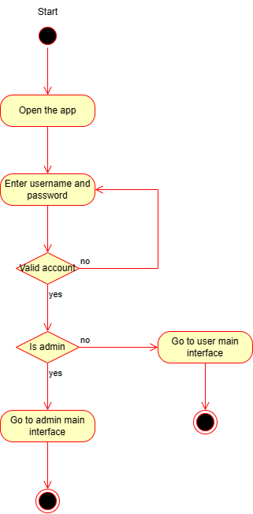

* Sign-up

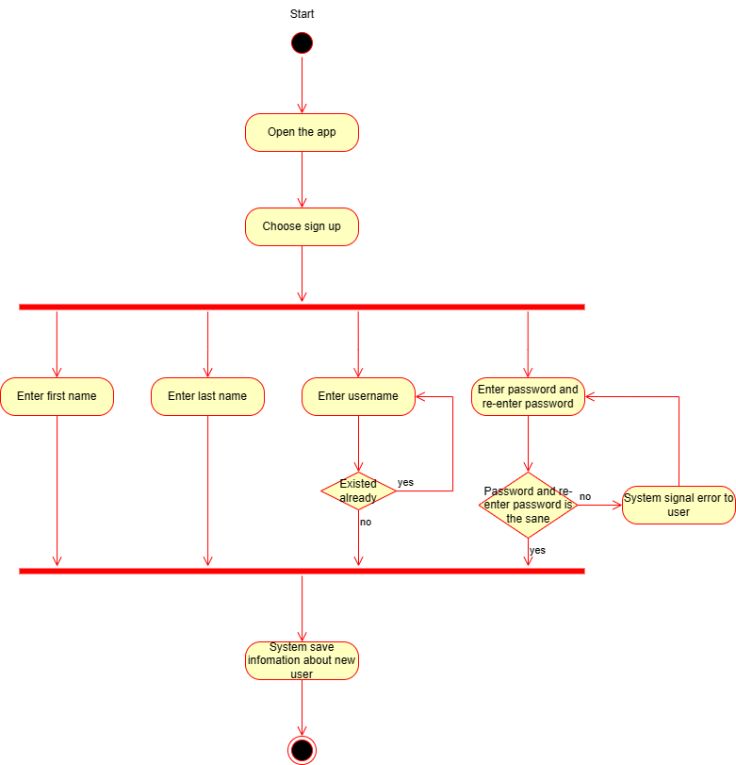

* Change Password

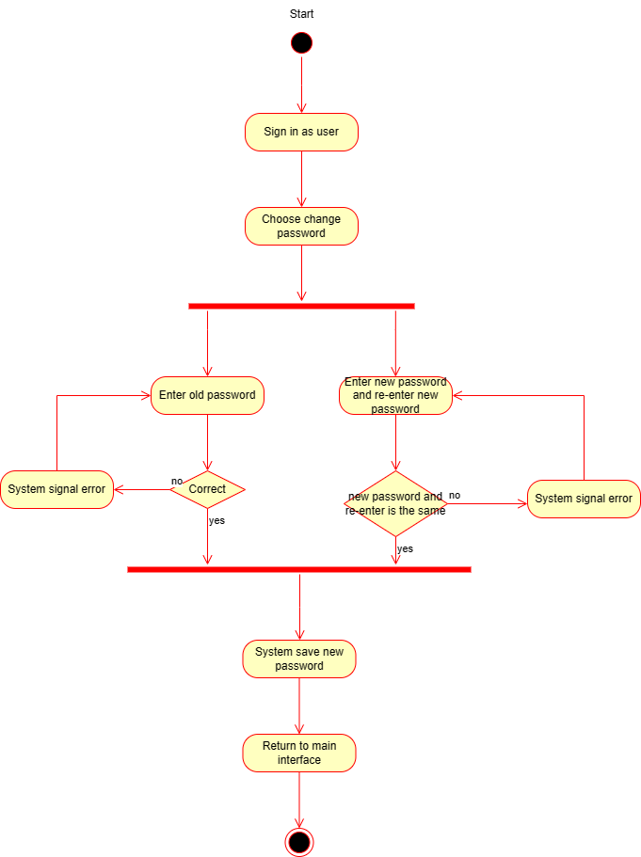

* Delete User

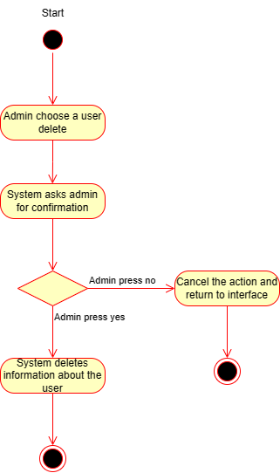

* Create room

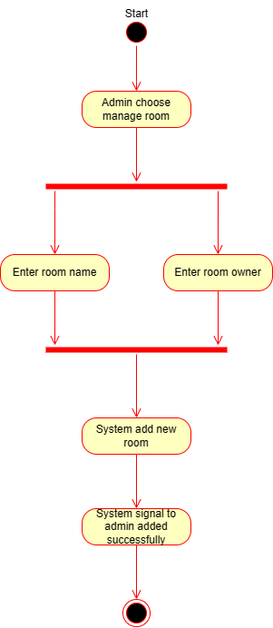

* Delete Room

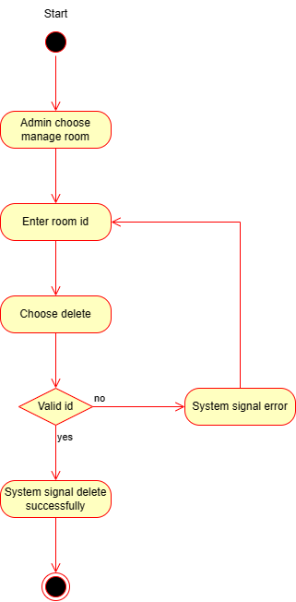

* Browse room

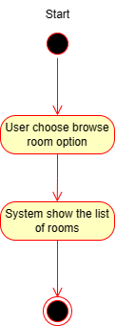

1. **ER model and RR model**

* ER Model

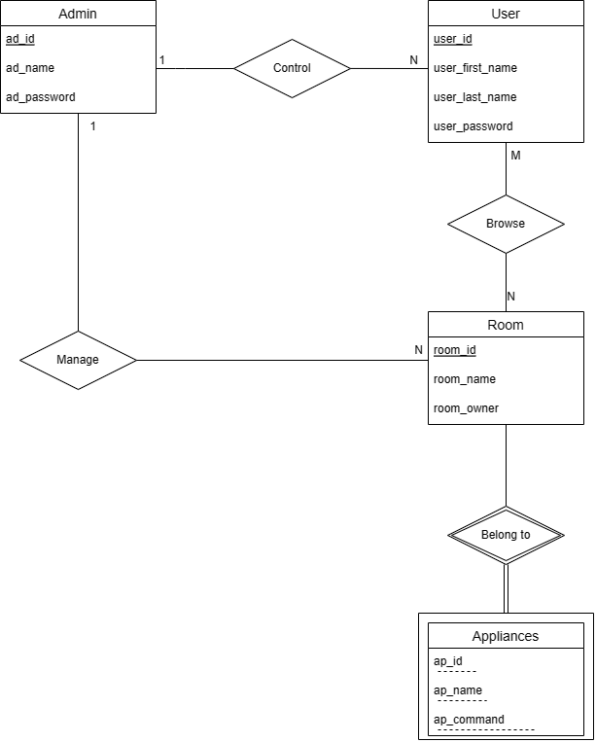

* RR Model

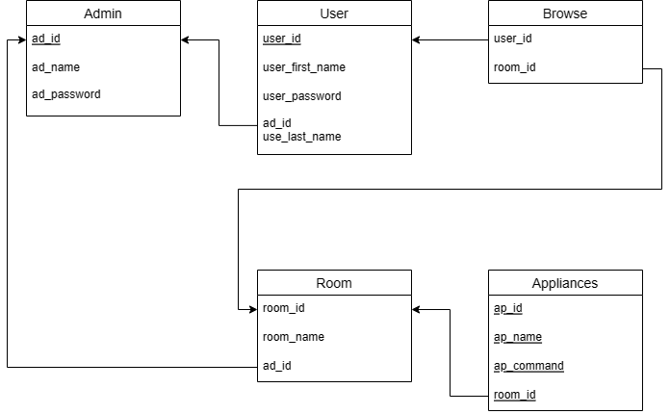

1. **Implementation**
2. **Tool**

* Programming Language: C++ Winform
* IDE: Visual Studio
* Database: SQL
* Design: Photoshop
* Diagram plotting: Diagrams.net

1. **Application Guide**

* When you open the app, it first appears the Login form. If you have an account or you are the admin, just simply login to the app. The default admin account is:

+ Username: admin

+ Password: admin

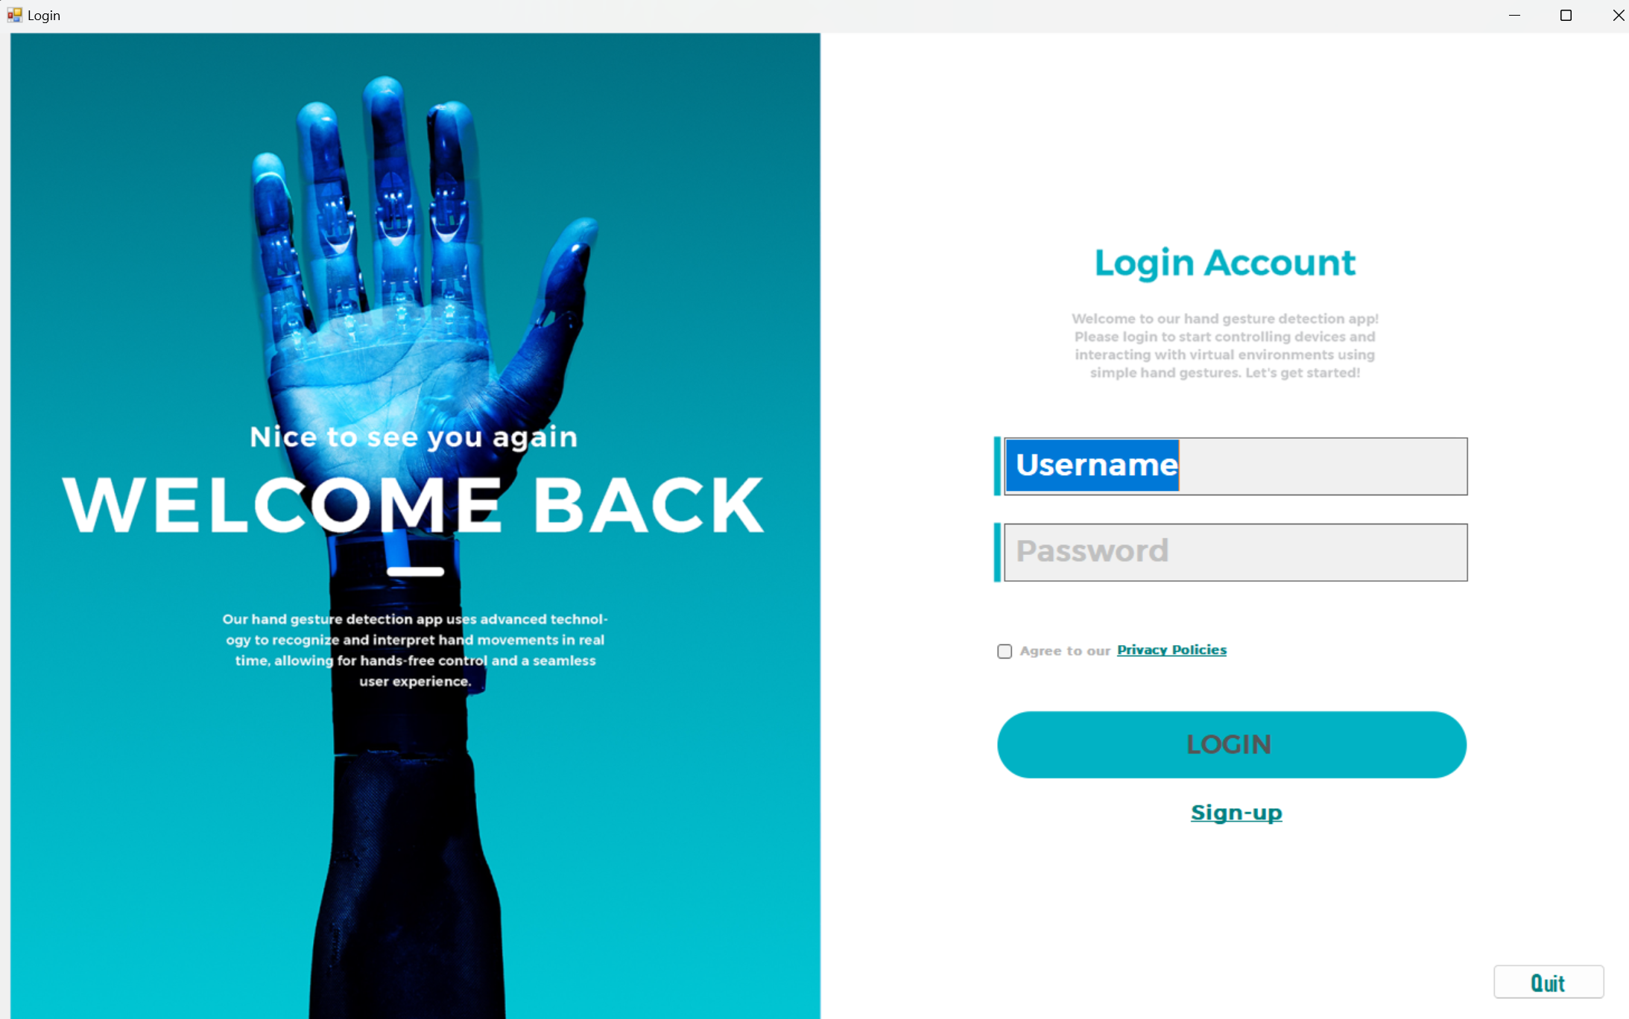

* If you don’t have a account, click Sign-up, the registration form appears and you need to enter your information to create an account.

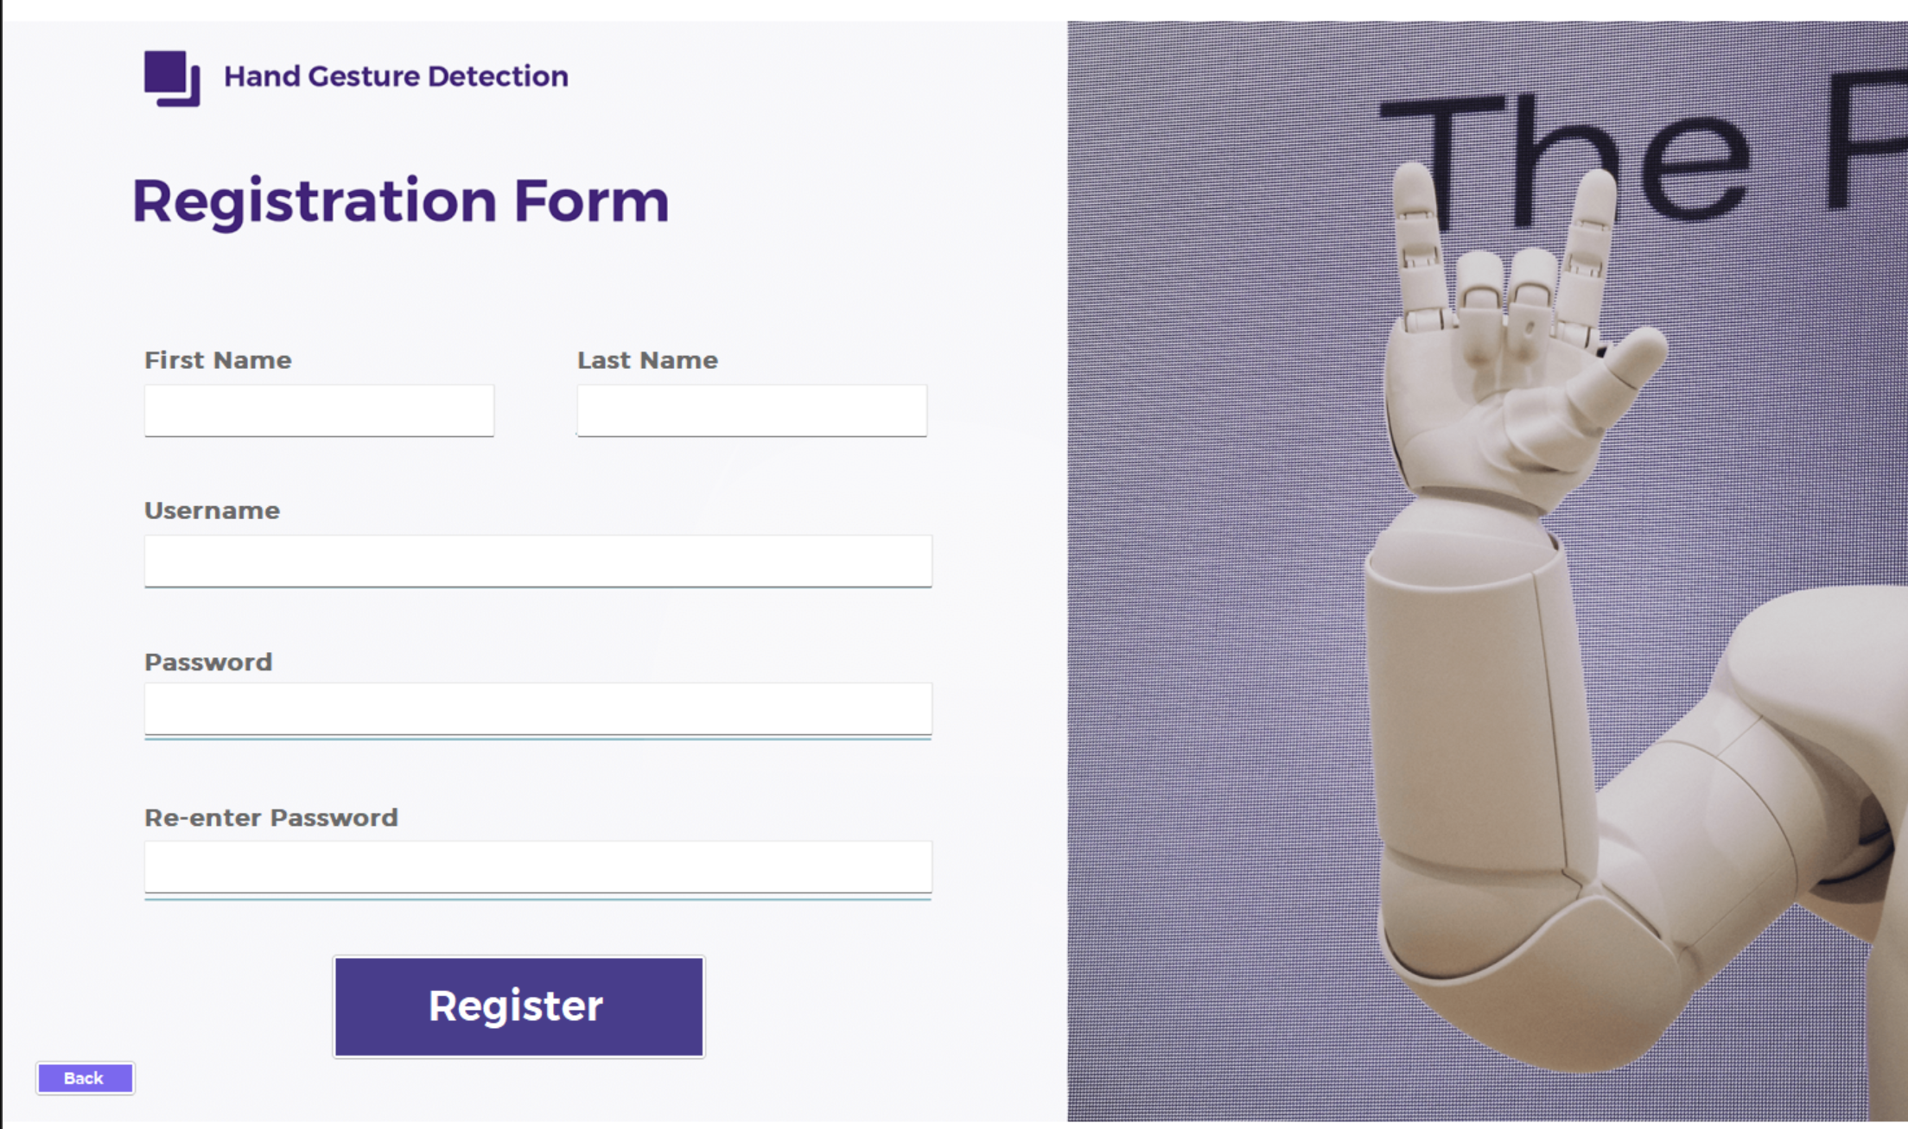

* For admin:
* When you login as an admin, the application shows you the admin interface. To open the menu for admin, simply click the menu button at the top left of the window.

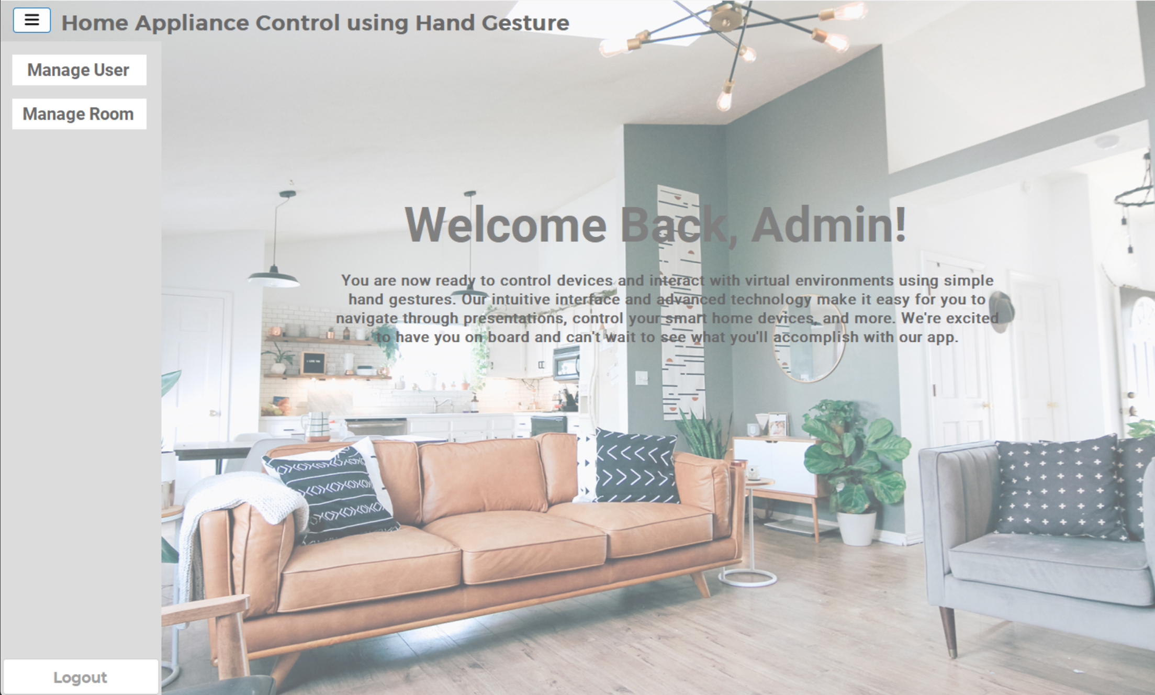

* Manage User: When you click on the “Manage User” button, the app shows you a panel where you can see all the users and delete a user. The orther buttons that are out of the “Manage User” panel is disabled until you click the “Back” button.

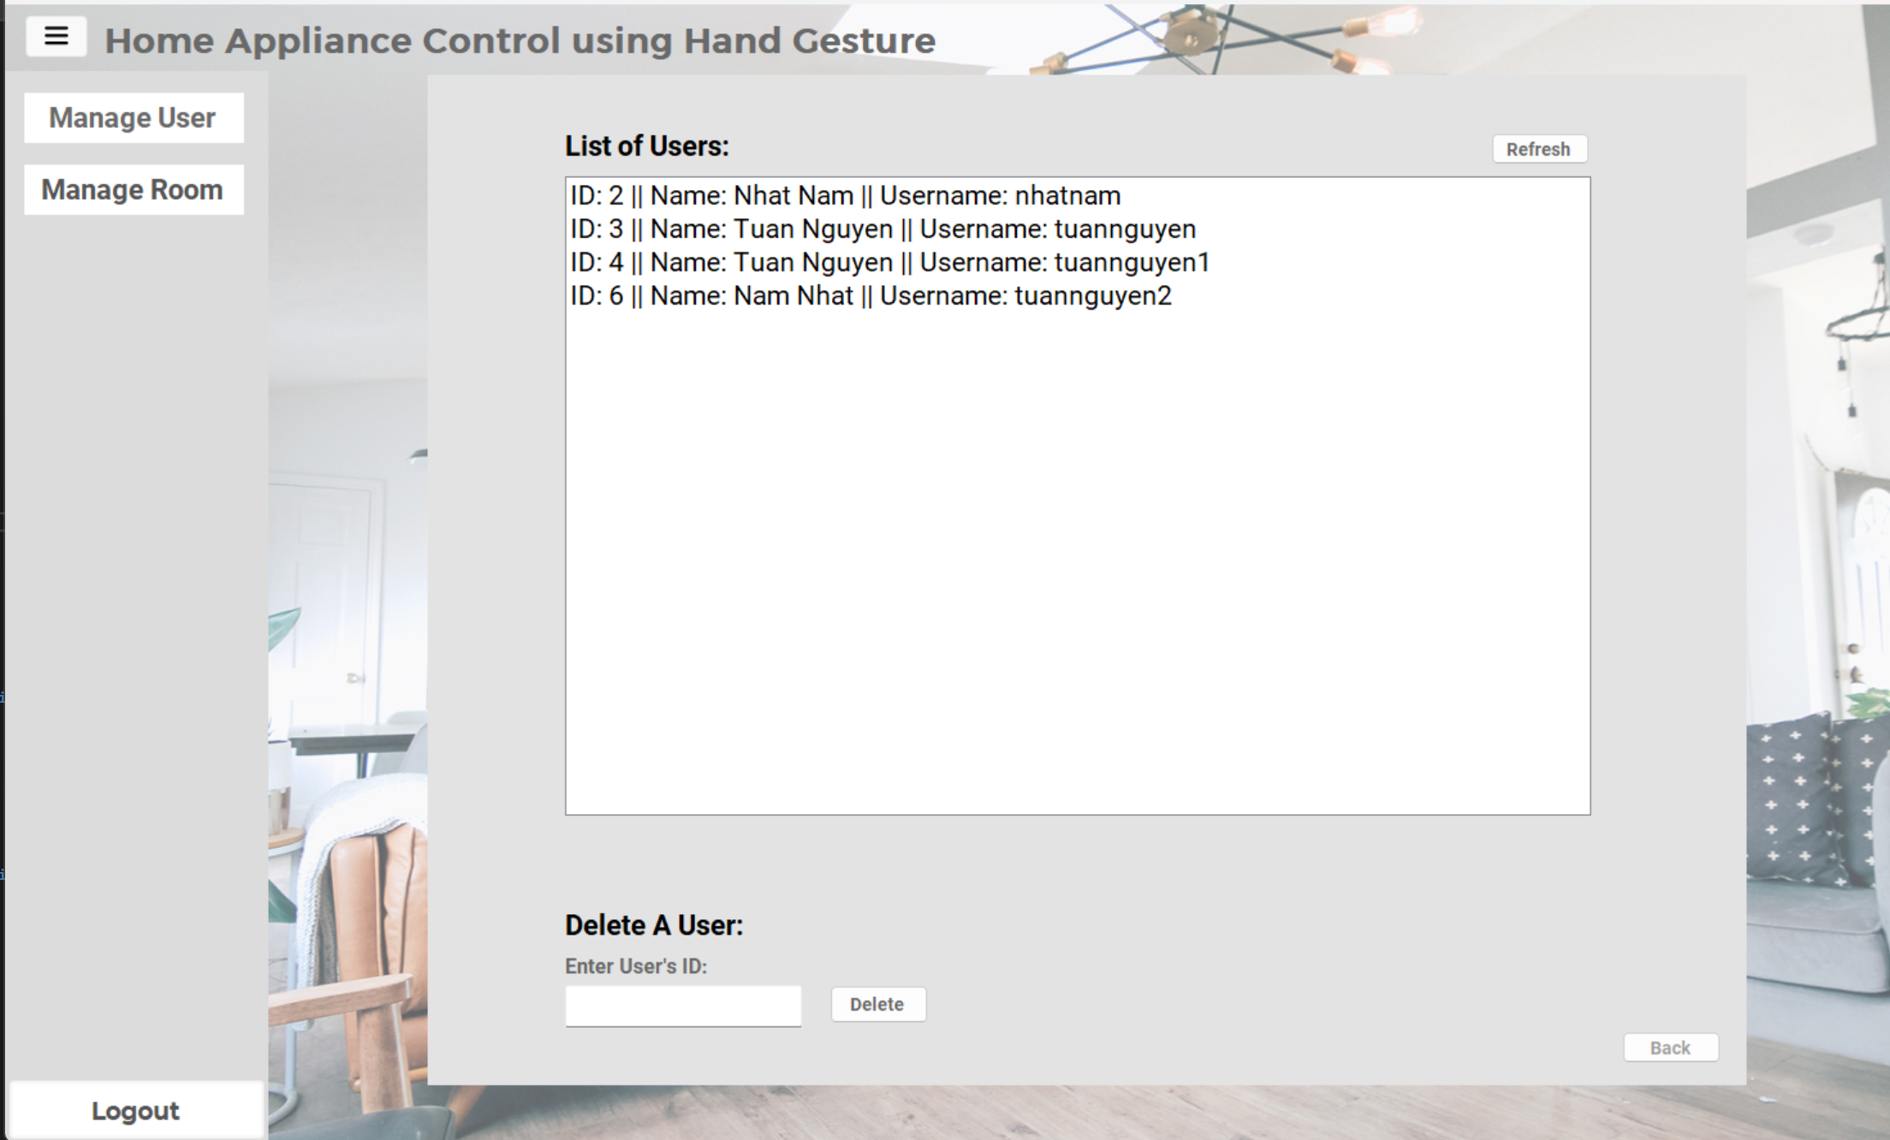

* Manage Rooms: When you click on “Manage Room” button, the app shows you a panel where you can see all the rooms, add a room or delete a room. The orther buttons that are out of the “Manage Room” panel is disabled until you click the “Back” button.

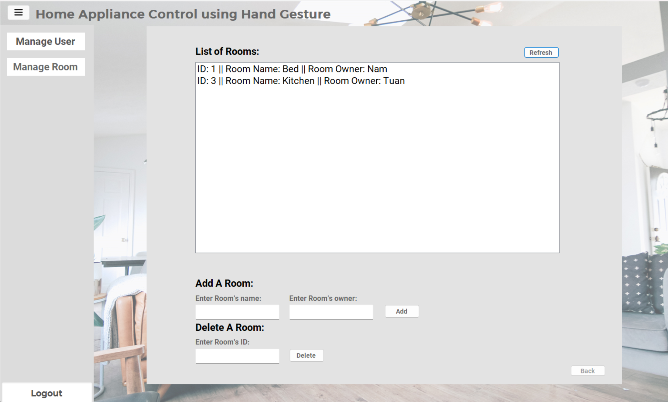

* For user:
* When you login as a user, the application shows you the user interface. To open the menu for users, simply click the menu button at the top left of the window.

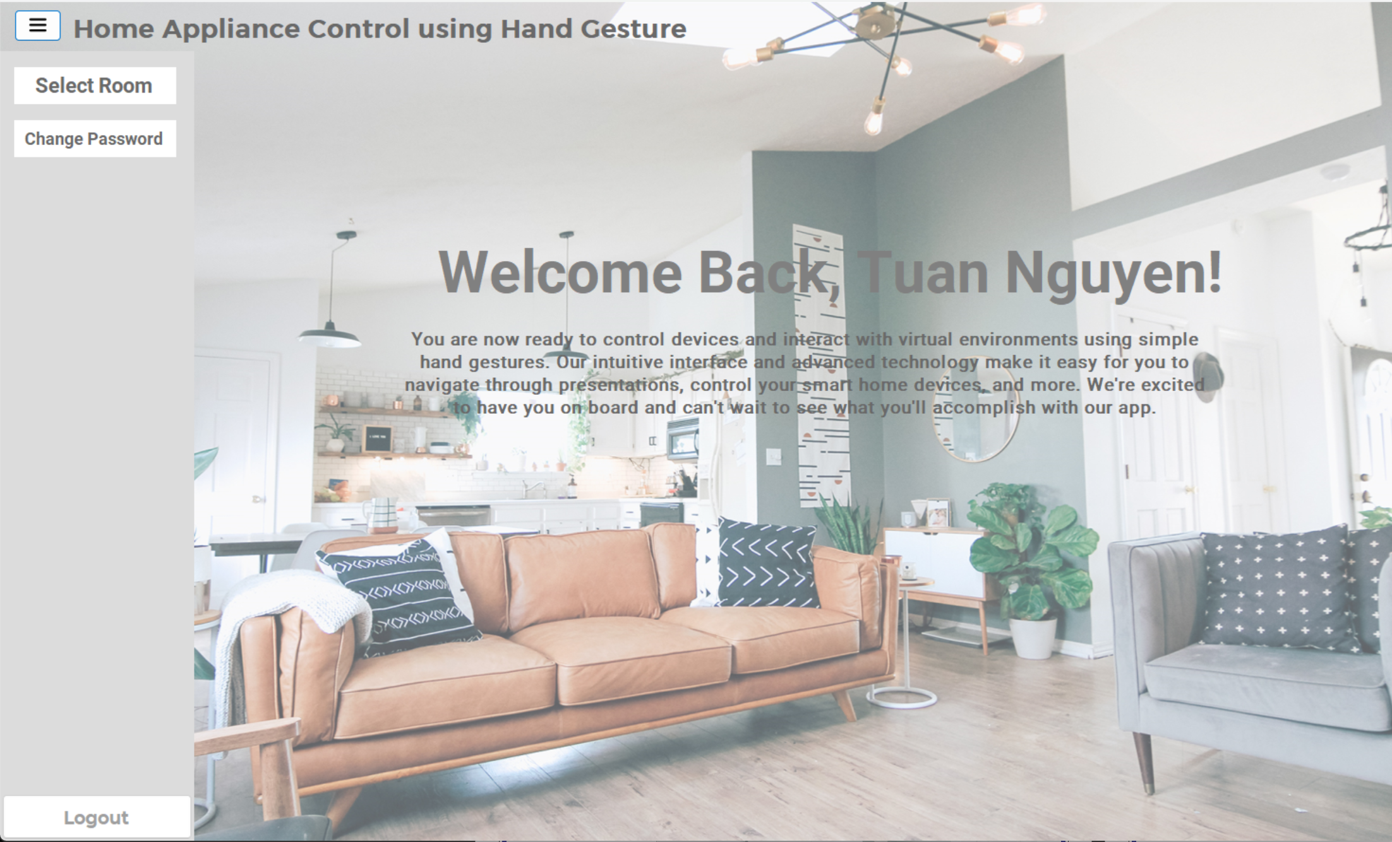

* When you click on the “Change Password” button, the app shows you a panel where you can change your password.

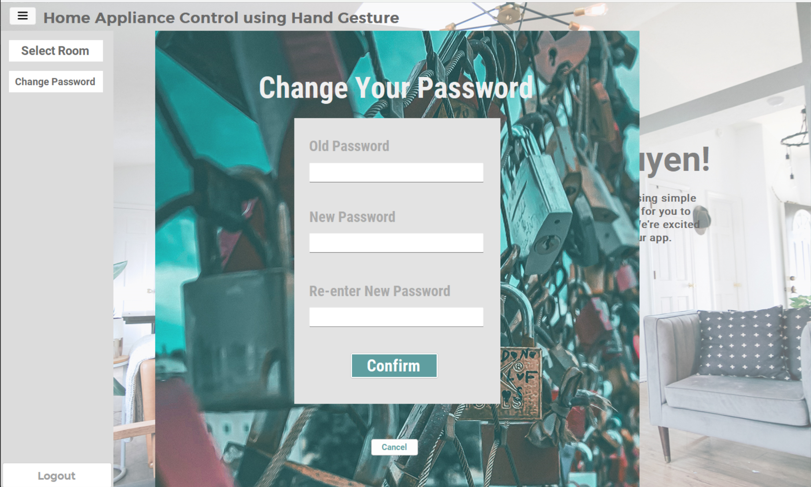

* When you click on “Select Room” button, the app will show you the “Select Room” panel that allows you to choose which room you will be interact and the appliances available for that room.

1. **Conclusion and Future Work**

In conclusion, the application for home appliance control using hand gestures is a promising technology that offers numerous benefits to users seeking a more convenient and intuitive way of controlling their home appliances. The application leverages the power of machine learning and computer vision to interpret hand gestures, enabling users to control their devices without having to physically interact with them.

However, to ensure the success of the application, it is important to consider the non-functional requirements such as performance, security, reliability, usability, compatibility, scalability, accessibility, availability, maintenance, and privacy. These requirements are essential for the application's success, and they need to be carefully considered during the development and deployment stages.

Furthermore, the potential impact of the application on the home automation industry is significant, as it offers a unique and innovative solution to improve the convenience and automation of households. As the technology advances and becomes more widely adopted, it is likely that the application will continue to evolve and improve, further enhancing its capabilities and benefits to users.

In the future, we will continue to develop our application. We will integrate the hand gesture recognition and device control into the app to fully complete our application.

Overall, the application for home appliance control using hand gestures represents a significant advancement in the home automation industry, and it has the potential to revolutionize the way we interact with our home appliances. With the right attention to non-functional requirements and continued innovation, this technology can provide users with a more intuitive, convenient, and automated home environment.